**Ultrasonic Sensor: -** Ultrasonic sensors are electronic devices that calculate the target’s distance by emission of ultrasonic sound waves and convert those waves into electrical signals. To know the distance between the target and the sensor, the sensor calculates the amount of time required for sound emission to travel from transmitter to receiver. The calculation is done as follows:

**D = 1/2 T * C**

**The ultrasonic sensor working principle** is either like sonar or radar which evaluates the target/object attributes by understanding the received echoes from sound/radio waves correspondingly. These sensors produce high-frequency sound waves and analyse the echo which is received from the sensor. The sensors measure the time interval between transmitted and received echoes so that the distance to the target is known.

This section explains the interfacing of the ultrasonic sensor with an Arduino by considering HC-SR-04 where it explains the ultrasonic sensor pinout, its specifications, wiring diagram, and how the sensor with an Arduino connection.

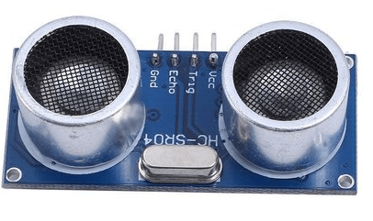

**Vcc** – This pin has to be connected to a power supply of +5V.

**TRIG** – This pin is used to receive controlling signals from the Arduino board. This is the triggering input pin of the sensor.

**ECHO** – This pin is used for sending signals to the Arduino board where the Arduino calculates the pulse duration to know the distance. This pin is the ECHO output of the sensor.

**GND** – This pin must be connected to the ground.

The below picture shows the **ultrasonic sensor block diagram** for distance measurement.

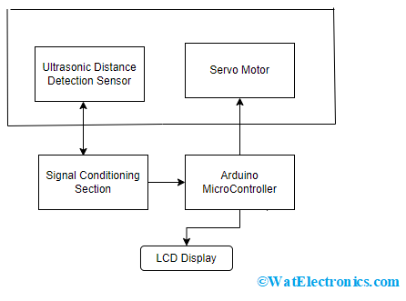

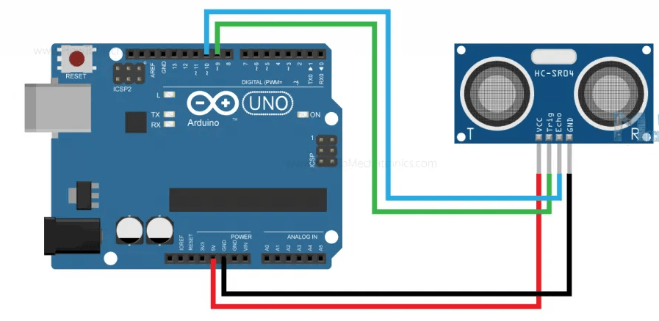

[Integration of Ultrasonic Transducer with Arduino](https://howtomechatronics.com/)

**Resistor:** A passive electrical component with two terminals that are used for either limiting or regulating the flow of electric current in electrical circuits. The main purpose of a resistor is to reduce the current flow and lower the voltage in any particular portion of the circuit.

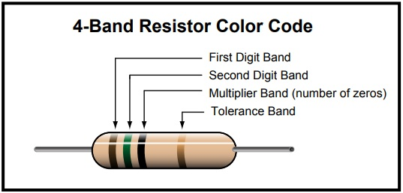

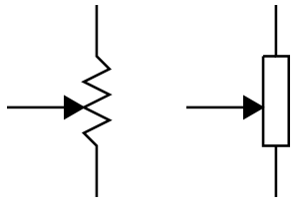Potentiometer: -

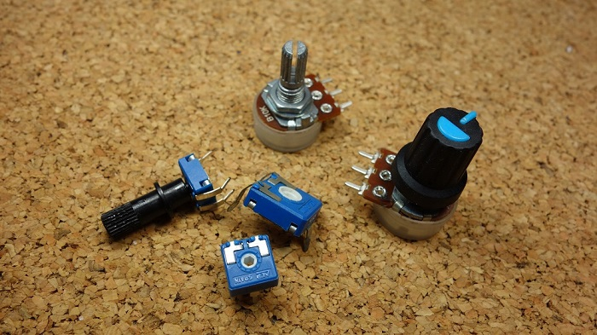is defined as a 3-terminal variable resistor in which the resistance is manually varied to control the flow of electric current. A potentiometer acts as an adjustable voltage divider**. symbol**

Potentiometers work by varying the position of a sliding contact across a uniform resistance. In a potentiometer, the entire input voltage is applied across the whole length of the resistor, and the output voltage is the voltage drop between the fixed and sliding contact as shown below.

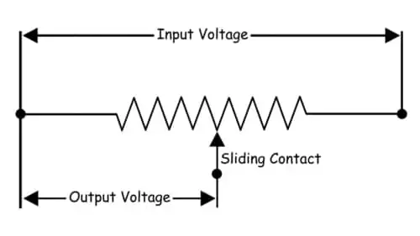

**Arduino -** Arduino is an open-source electronics platform based on easy-to-use hardware and software. Arduino boards are able to read inputs – a light on a sensor, a finger on a button, or a Twitter message - and turn them into an output - activating a motor, turning on an LED, or publishing something online.

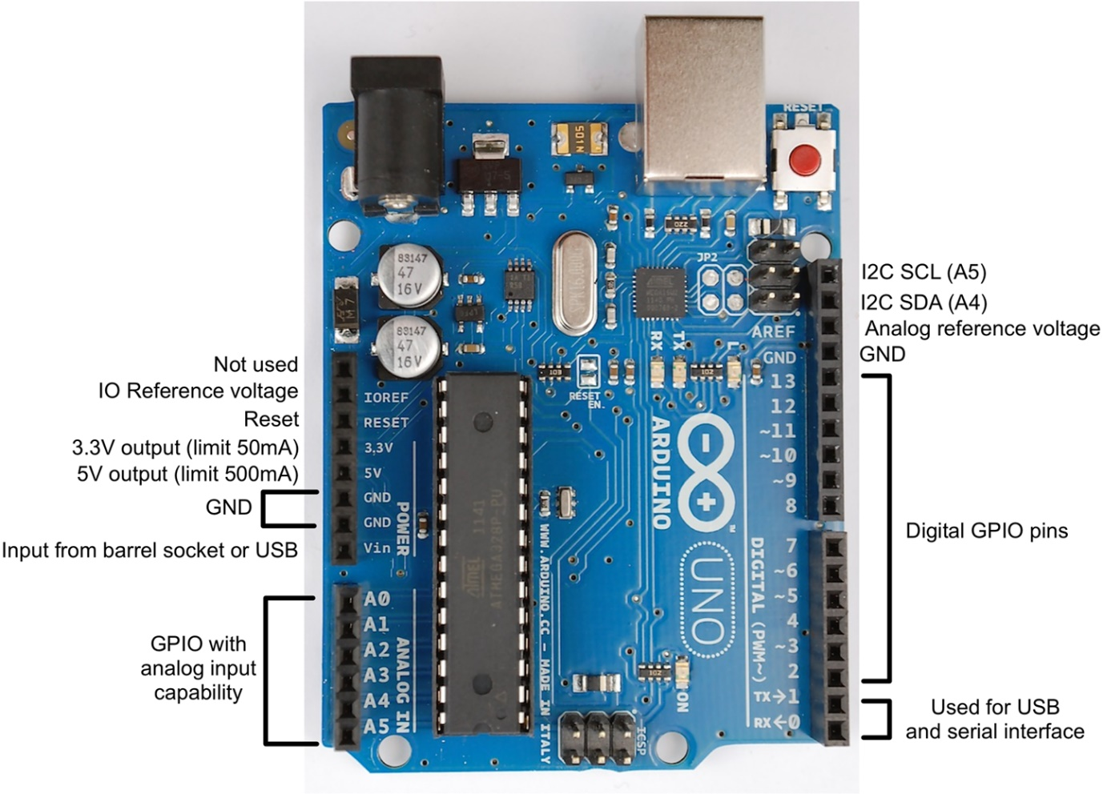

**Arduino Uno** is a microcontroller board based on 8-bit ATmega328P microcontroller. Along with ATmega328P, it consists other components such as crystal oscillator, serial communication, voltage regulator, etc. to support the microcontroller. Arduino Uno has 14 digital input/output pins (out of which 6 can be used as PWM outputs), 6 analog input pins, a USB connection, A Power barrel jack, an ICSP header and a reset button.